**Professional Practice for Game Development**

**Session 5. Strategic and Twitch Skill**

5.1 Background:

The task was to create a strategic bomb defusal game which must use a timer which leads to the bomb exploding if the player fails to defuse it before it reaches 0. The game is to be played by 2 players which will be working together to defuse the bomb.

5.2 Materials:

The game will be played on computers so will require a mouse and keyboard along with a computer capable of running the game. The computer will also require an internet connection to allow players to team up online.

5.3 The game:

After discussing ideas, the game that we designed was called Bomb Defuser. In this game the players must complete various randomly generated puzzles while a bomb counts down [A.]. Examples of puzzles are: A password where the answer is figured out by doing other puzzles [B.], counting prime numbers [C.], Sudoku [D.] and cutting wires and connecting a defuser[E.].

The game is played on a computer and the playing area would be the bomb as all the puzzles would be located on it. The players can look around the bomb and focus on different areas of it to allow them to complete their puzzles.

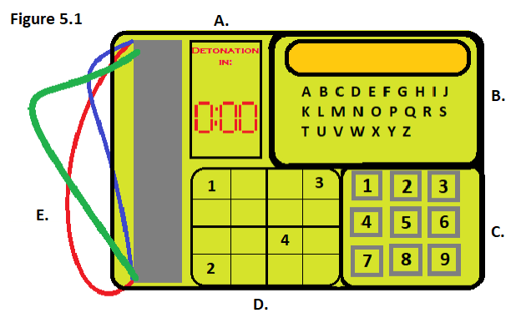

5.4 Rules:

1) You must work with your teammate to defuse the bomb.

2) Do not purposely fail tasks and waste time.

3) Do not research answers whilst playing a game.

4) Do not sabotage your teammate in anyway.

5.5 Play Testing:

For our play testing we had Steve Yap test our game. The feedback received was:

1. Players may not know where to locate the defuser after cutting the wires.
2. The task of sudoku may take too long to complete but it could still be possible.
3. It should be stated how long the players have until the bomb detonates within the game’s instruction manual.

Responding to the feedback:

Based on this feedback we made the following changes to our game.

1. There were no changes made because of this. This is because the final product was planned to have an item labelled “Defuser” next to the bomb which the player will be able to clearly see.
2. We adjusted the size of the sudoku boards, originally there were 4 sudoku boards at sizes 3x3 however we changed this to 4 boards of 2x2 to shorten the time taken slightly.
3. We added the bomb detonation time into the manual, the time we decided on was 5 minutes.

5.6 Conclusion:

My team and I worked well together despite having a slower start to the task. At the beginning our communication was rather poor due to conflicting ideas however we managed to improve this by listening to each other and taking other ideas on board.

Reece Taylor, Rowan Noble, Jamie Smith, Akash Sroay